

**LAB PROJECT PROPOSAL**

**Group Members** :

1. Fizza Razzaq
2. Hamza Jadoon
3. Ahad Abbasi

**Registration Numbers** : FA22-BCE-100

FA22-BCE-012

FA22-BCE-004

**Class/Section** :BCE-3A

**Course Teacher Name** :Sir MUHAMMAD ARIF

**Submission Date**  :4-11-2023

**TITLE:**

**“**TRAFFIC LIGHT CONTROL SYSTEM”

**COMPONENTS USED:**

1. 555 Timer IC x 2
2. 100 microF Capacitor x 2
3. 100k ohm Resistor
4. 47k ohm Resistor
5. 390 ohm Resistor x 2
6. 330 ohm Resistor
7. Breadboard
8. Connecting Wires

**CIRCUIT DIAGRAM:**

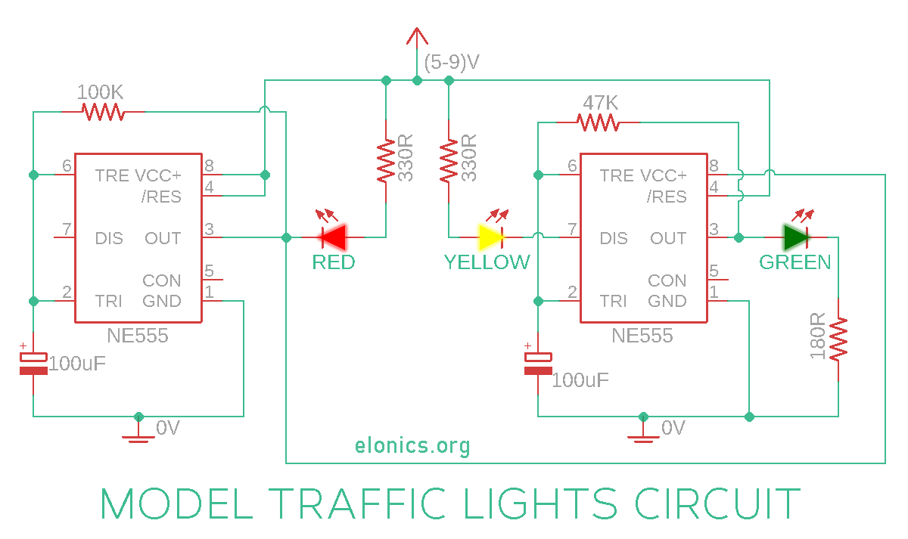

**Construction:**

1. Place a 555 timer ic on breadboard.
2. Connecting the ic pins with the help of connecting wires i.e
3. Pin 1 to negative trial
4. Pin 8 to plus trial.
5. Pin 4 to pin 8.
6. Pin 2 to pin 6.
7. Connect a 100k ohm resister to pin 3 and pin 6
8. Connect 100uf capacitor to pin 2 and negative trial.
9. Place another 555 timer.
10. Pin 3 to pin 8 of second 555 timer IC.
11. Pin 1 to negative trial of 2nd 555 timer
12. Connect a 47k ohm resistor to pin 3 to pin 6.
13. Pin 4 to negative trial of 2nd ic.
14. Connect a 100uf capacitor to pin 2 and negative trial(2nd ic).
15. Place a 5mm red led(Cathode = negative , anode= positive.)
16. Place a 5mm yellow led where cathode pin parallel to red led and anode to a separate pin.
17. Connect anode of both leds to positive trial.
18. Pin 3 of 1st 55 timer ic to cathode pin of red led through a 390 ohm resistor.
19. Connect a 390 ohm resistor.
20. Connect the cathode pin of yellow led via 390ohm resistor to pin 7 of 2nd 555 timer ic.
21. Place a 5mm green led.
22. Connect pin 3 of 2nd 555 timer ic to anode pin of green led.
23. Place a 330 ohm resistor.
24. Connect a cathode pin via 330 ohm resistor to the negative trial.
25. Input voltage 9v.
26. Timing of leds can be adjust by changing the values of capacitor and resistor.